AC EV Charger
Type 2, Mode 3 — System Flow & Firmware Architecture
State-machine flow diagrams and a modular STM32 firmware architecture
Part A — System Flow · Part B — Firmware Architecture

Contents
Contents 2
Part A — System Flow 3
System Overview 3
State 1 — POWER ON / STARTUP 5
State 2 — INITIALIZATION 5
State 3 — SELF TEST 5
State 4 — IDLE / WAIT FOR EV 6
State 5 — EV CONNECTED 6
State 6 — AUTHORIZATION 7
State 7 — CHARGING PREPARATION / CP NEGOTIATION 7
State 8 — FINAL SAFETY CHECK 8
State 9 — CHARGING 10
State 10 — STOPPING 12
State 11 — SESSION END 12
State 12 — WAIT FOR UNPLUG 12
State 13 — FAULT 13
Part B — Firmware Architecture 16
B.1 Architecture Layers 16
B.2 Module Responsibilities 17
B.3 State Machine Implementation Summary 18
B.4 Safety Architecture 19
Fault severity classes 19
Where firmware alone is not the protection boundary 19
B.5 Contactor Control Ownership 19
B.6 Control Pilot (CP) Subsystem 19
B.7 Measurement Architecture 19
B.8 Fault Record Structure 20
B.9 Execution Model 20
B.10 Suggested STM32CubeIDE Project Structure 20

Part A — System Flow
This section walks through the charger's complete lifecycle, state by state, in the order a session actually happens: from power-on, through self-test, connection, authorization, and charging, to a controlled stop and session close-out — with a fault path that can be entered from almost anywhere. Each state below follows the same structure: purpose, entry conditions, key activities and checks, outputs, and exit conditions. The three states with the most internal branching — Final Safety Check, Charging, and Fault — also include a detailed flow diagram.

System Overview
The charger moves through 13 states. The normal path is linear — each state hands off to the next once its own conditions are satisfied — and a critical safety condition can interrupt that path from any state and route directly to FAULT. Figure 1 shows the complete picture; the sections that follow go through each state in detail.
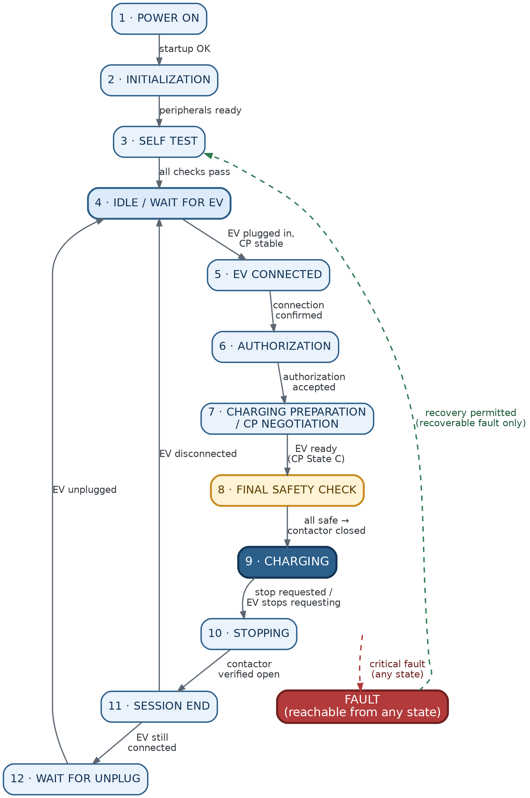
Figure 1. Complete EVSE state machine — happy path (solid) and fault path (dashed).

State 1 — POWER ON / STARTUP
Purpose: Bring the MCU into a known, safe condition immediately after power is applied — before any measurement or control activity begins.
Entry conditions: AC power is applied to the charger and the STM32 receives power and begins its reset/boot sequence.
Key activities & checks:
- Power supply stabilizes; MCU resets and boots.
- Firmware immediately forces all outputs to a safe default: contactor command OFF, CP output inactive/safe, charging disabled.
- Fault and status variables are initialized to known values.
- Only basic MCU startup happens here — peripheral configuration is deliberately deferred to INITIALIZATION, so this state stays fast and minimal.
Outputs: Contactor OFF; CP inactive; charging not permitted.
Exit → next state(s): Startup completes successfully → INITIALIZATION. Startup failure → FAULT (contactor stays OFF).

State 2 — INITIALIZATION
Purpose: Configure every MCU peripheral, hardware interface, and software module the charger needs. The contactor remains OFF throughout.
Entry conditions: Entered from POWER ON once safe output defaults are established.
Key activities & checks:
- GPIO: contactor control/feedback, RCM input, emergency stop, LEDs, buzzer.
- ADC channels: AC voltage, AC current, CP voltage, temperature (if analog).
- ADC sampling timer and CP PWM timer.
- Safety inputs (RCM, E-stop, contactor feedback) are made readable here — not yet evaluated for a healthy condition.
- RFID reader interface (SPI), communication interfaces (CAN/UART/backend).
- Measurement software: buffers, sample index, RMS/energy accumulators, filters — all reset to zero.
- Session data structures reset.
Outputs: All peripherals configured and ready; contactor remains OFF.
Exit → next state(s): All modules initialize successfully → SELF TEST. Initialization failure → FAULT.

Important distinction carried through the whole design: “initialized” only means a peripheral is configured and ready — it says nothing about whether the underlying physical condition is actually healthy. “ADC initialized” is not the same claim as “AC voltage is within range.” That verification is SELF TEST's job, not INITIALIZATION's.

State 3 — SELF TEST
Purpose: With peripherals configured, verify that the actual hardware and electrical conditions are healthy before any operation is allowed. Contactor stays OPEN throughout.
Entry conditions: Entered from INITIALIZATION after successful peripheral setup.
Key activities & checks:
- AC input voltage within valid range (via Vrms calculation from live ADC samples).
- Measured charging current ≈ 0 A — contactor is open, so any significant current is suspicious and must be investigated.
- RCM/leakage input clear.
- Emergency stop not active.
- Contactor feedback consistent with the commanded OFF state — feedback should read OPEN; feedback reading CLOSED while commanded OFF flags a possible welded contactor.
- CP circuit behaves plausibly — interpreted according to whether a vehicle happens to already be connected, rather than assuming a specific state.
- Temperature and any other protection inputs within range.
Outputs: Charger declared healthy or faulted; contactor remains OFF either way.
Exit → next state(s): All critical checks pass → IDLE. Any critical check fails → FAULT.

State 4 — IDLE / WAIT FOR EV
Purpose: The charger is healthy and available but no session is active. Stay safe, keep monitoring, and wait for a valid EV connection.
Entry conditions: From SELF TEST (pass), or looping back from SESSION END / WAIT FOR UNPLUG once the previous vehicle has left.
Key activities & checks:
- Contactor held OFF (command = OFF, feedback expected = OPEN).
- CP presents the idle signal so an EV can detect the charging equipment.
- Full safety monitoring continues even with nothing connected — AC voltage, RCM, E-stop, temperature, contactor feedback, CP, internal faults. A critical fault here still routes straight to FAULT; IDLE is not a “safe to ignore” state.
- CP is watched for a connection change, but a single noisy ADC sample is never trusted — the CP condition must be stable for a defined period before being treated as a real vehicle connection.
Outputs: Contactor OFF; CP idle signal active.
Exit → next state(s): Critical fault → FAULT. Stable EV connection confirmed → EV CONNECTED. Otherwise → remain in IDLE.

State 5 — EV CONNECTED
Purpose: A vehicle has been detected through CP. Confirm the connection is genuine and stable, keep the contactor open, and prepare to request authorization.
Entry conditions: From IDLE, once a stable connected-CP condition has been confirmed.
Key activities & checks:
- Re-confirm the connection is still present — guards against a plug/unplug event occurring during the state transition itself.
- Contactor remains OFF: “EV connected” is explicitly not the same as “charging allowed.” Only the low-power CP link is active at this point.
- Full safety monitoring continues (RCM, E-stop, AC voltage, temperature, contactor feedback, CP validity, internal faults).
- Session bookkeeping is created/reset: session energy = 0, session time = 0, authorization = pending, charging = false.
- User is prompted to begin authorization (e.g. “Present RFID Card”).
Outputs: Contactor OFF; new session record created; authorization request issued.
Exit → next state(s): EV unplugged → IDLE. Critical fault → FAULT. Valid, stable connection with no fault → AUTHORIZATION.

State 6 — AUTHORIZATION
Purpose: Determine whether this user/session is permitted to charge — primarily via RFID, with app/backend as alternative paths. Authorization is strictly a permission check; it does not by itself start charging.
Entry conditions: From EV CONNECTED, with the vehicle confirmed present.
Key activities & checks:
- Contactor stays OFF throughout — even an accepted credential does not close the contactor directly; it only sets user_authorized = true and allows the flow to continue.
- EV connection is continuously re-checked while waiting for the user to authenticate; unplugging cancels the attempt and returns to IDLE.
- Full safety monitoring runs in parallel — a fault here aborts authorization and goes straight to FAULT.
- Credential is read and validated (locally or via backend).
- Rejected credential is normally a UX condition, not an electrical fault — display “Authorization Failed” and allow retry rather than faulting the charger.
- No response within the timeout cancels the pending session (timeout value is a product decision).
Outputs: user_authorized flag; session metadata (user/card ID, connector ID, authorization result).
Exit → next state(s): EV disconnected → IDLE. Critical fault → FAULT. Authorization accepted → CHARGING PREPARATION. Rejected or timed out → remain in AUTHORIZATION for retry.

State 7 — CHARGING PREPARATION / CP NEGOTIATION
Purpose: Authorization has succeeded, but the contactor still isn't closed. Work out how much current the EVSE can actually offer, advertise it to the EV over CP, and wait for the EV to accept and request energy.
Entry conditions: From AUTHORIZATION, once accepted.
Key activities & checks:
- Available current is derived from charger hardware rating, cable/connector limit, site/load-management limit, backend-configured limit, and thermal derating — the most restrictive of these is what gets advertised.
- The available current is converted into a CP PWM duty cycle and driven out continuously.
- While the EV remains in CP State B (connected, not yet requesting energy), the charger simply waits.
- When the EV is ready, CP transitions B → C; this transition is confirmed stable before the firmware treats the vehicle as “ready” (vehicle_ready = true) — again, no action on a single sample.
- Even with EV ready, authorized, and connected, the contactor is still not closed — that only happens after FINAL SAFETY CHECK passes.
- Full safety monitoring continues throughout.
- If the EV unplugs during preparation, this is a normal, safe cancellation — the contactor was never closed — and the charger returns to IDLE.
Outputs: CP PWM duty cycle set to the advertised current limit; vehicle_ready flag.
Exit → next state(s): EV disconnected → IDLE. Critical fault → FAULT. EV ready and stable (State C, all conditions holding) → FINAL SAFETY CHECK.

State 8 — FINAL SAFETY CHECK
Purpose: The last checkpoint before the contactor closes — reconfirm every condition required to safely energize the EV, using fresh measurements, immediately before doing so.
Entry conditions: From CHARGING PREPARATION, with EV connected, authorized, ready (CP State C), and CP PWM valid — contactor still open.
Key activities & checks:
- Re-verify EV connection, authorization, and CP State C / PWM validity haven't changed since entry.
- Fresh checks (not stale/cached values): AC voltage in range, RCM clear, E-stop clear, temperature acceptable, contactor feedback still reads OPEN, and no unexpected current is already flowing.
- All of the above combine into a single explicit “safe to energize” decision — every condition must hold simultaneously.
- Only once that decision is TRUE does the firmware command the contactor ON.
- Contactor closure is then verified via feedback within a timeout window — the command being issued is never assumed to mean the contacts actually closed.
Outputs: Contactor close command; charging_active = TRUE only after feedback confirms CLOSED.
Exit → next state(s): EV no longer ready (State C→B) → back to CHARGING PREPARATION. Any safety condition fails → FAULT. Closure times out → FAULT (failed to close). All checks pass and closure confirmed → CHARGING.
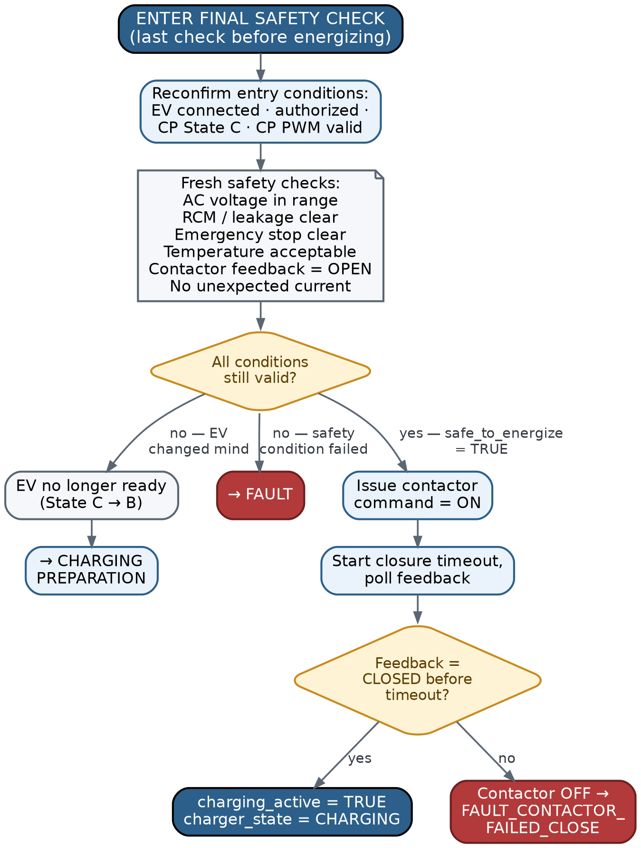
Figure 2. Final Safety Check — detailed decision logic.

State 9 — CHARGING
Purpose: Deliver power to the EV while continuously monitoring measurements, CP, safety inputs, and the contactor, for as long as the session remains valid.
Entry conditions: From FINAL SAFETY CHECK, with the contactor confirmed closed.
Key activities & checks:
- Every monitoring cycle: acquire V/I samples → compute Vrms/Irms/power → accumulate session energy.
- CP subsystem stays active and is continuously validated — it does not become irrelevant once the contactor closes.
- RCM and E-stop are checked every cycle as the highest-priority conditions.
- Temperature uses staged handling: normal → derate (reduce advertised current) → shutdown, rather than turning every temperature rise straight into a fault.
- Measured current is compared against the advertised CP limit; contactor feedback is continuously cross-checked against the ON command.
- Current-limit changes (thermal derating, or a backend/site-load update) are pushed out by recalculating and re-advertising the CP duty cycle — the limit is not assumed constant for the whole session.
Outputs: Live measurement values; updated CP PWM when the limit changes; growing session energy total.
Exit → next state(s): Critical safety fault → contactor opened immediately → FAULT. EV stops requesting energy (State C→B) or disconnects (State A) → STOPPING. User / RFID / backend stop request → STOPPING. Otherwise → continue the loop.
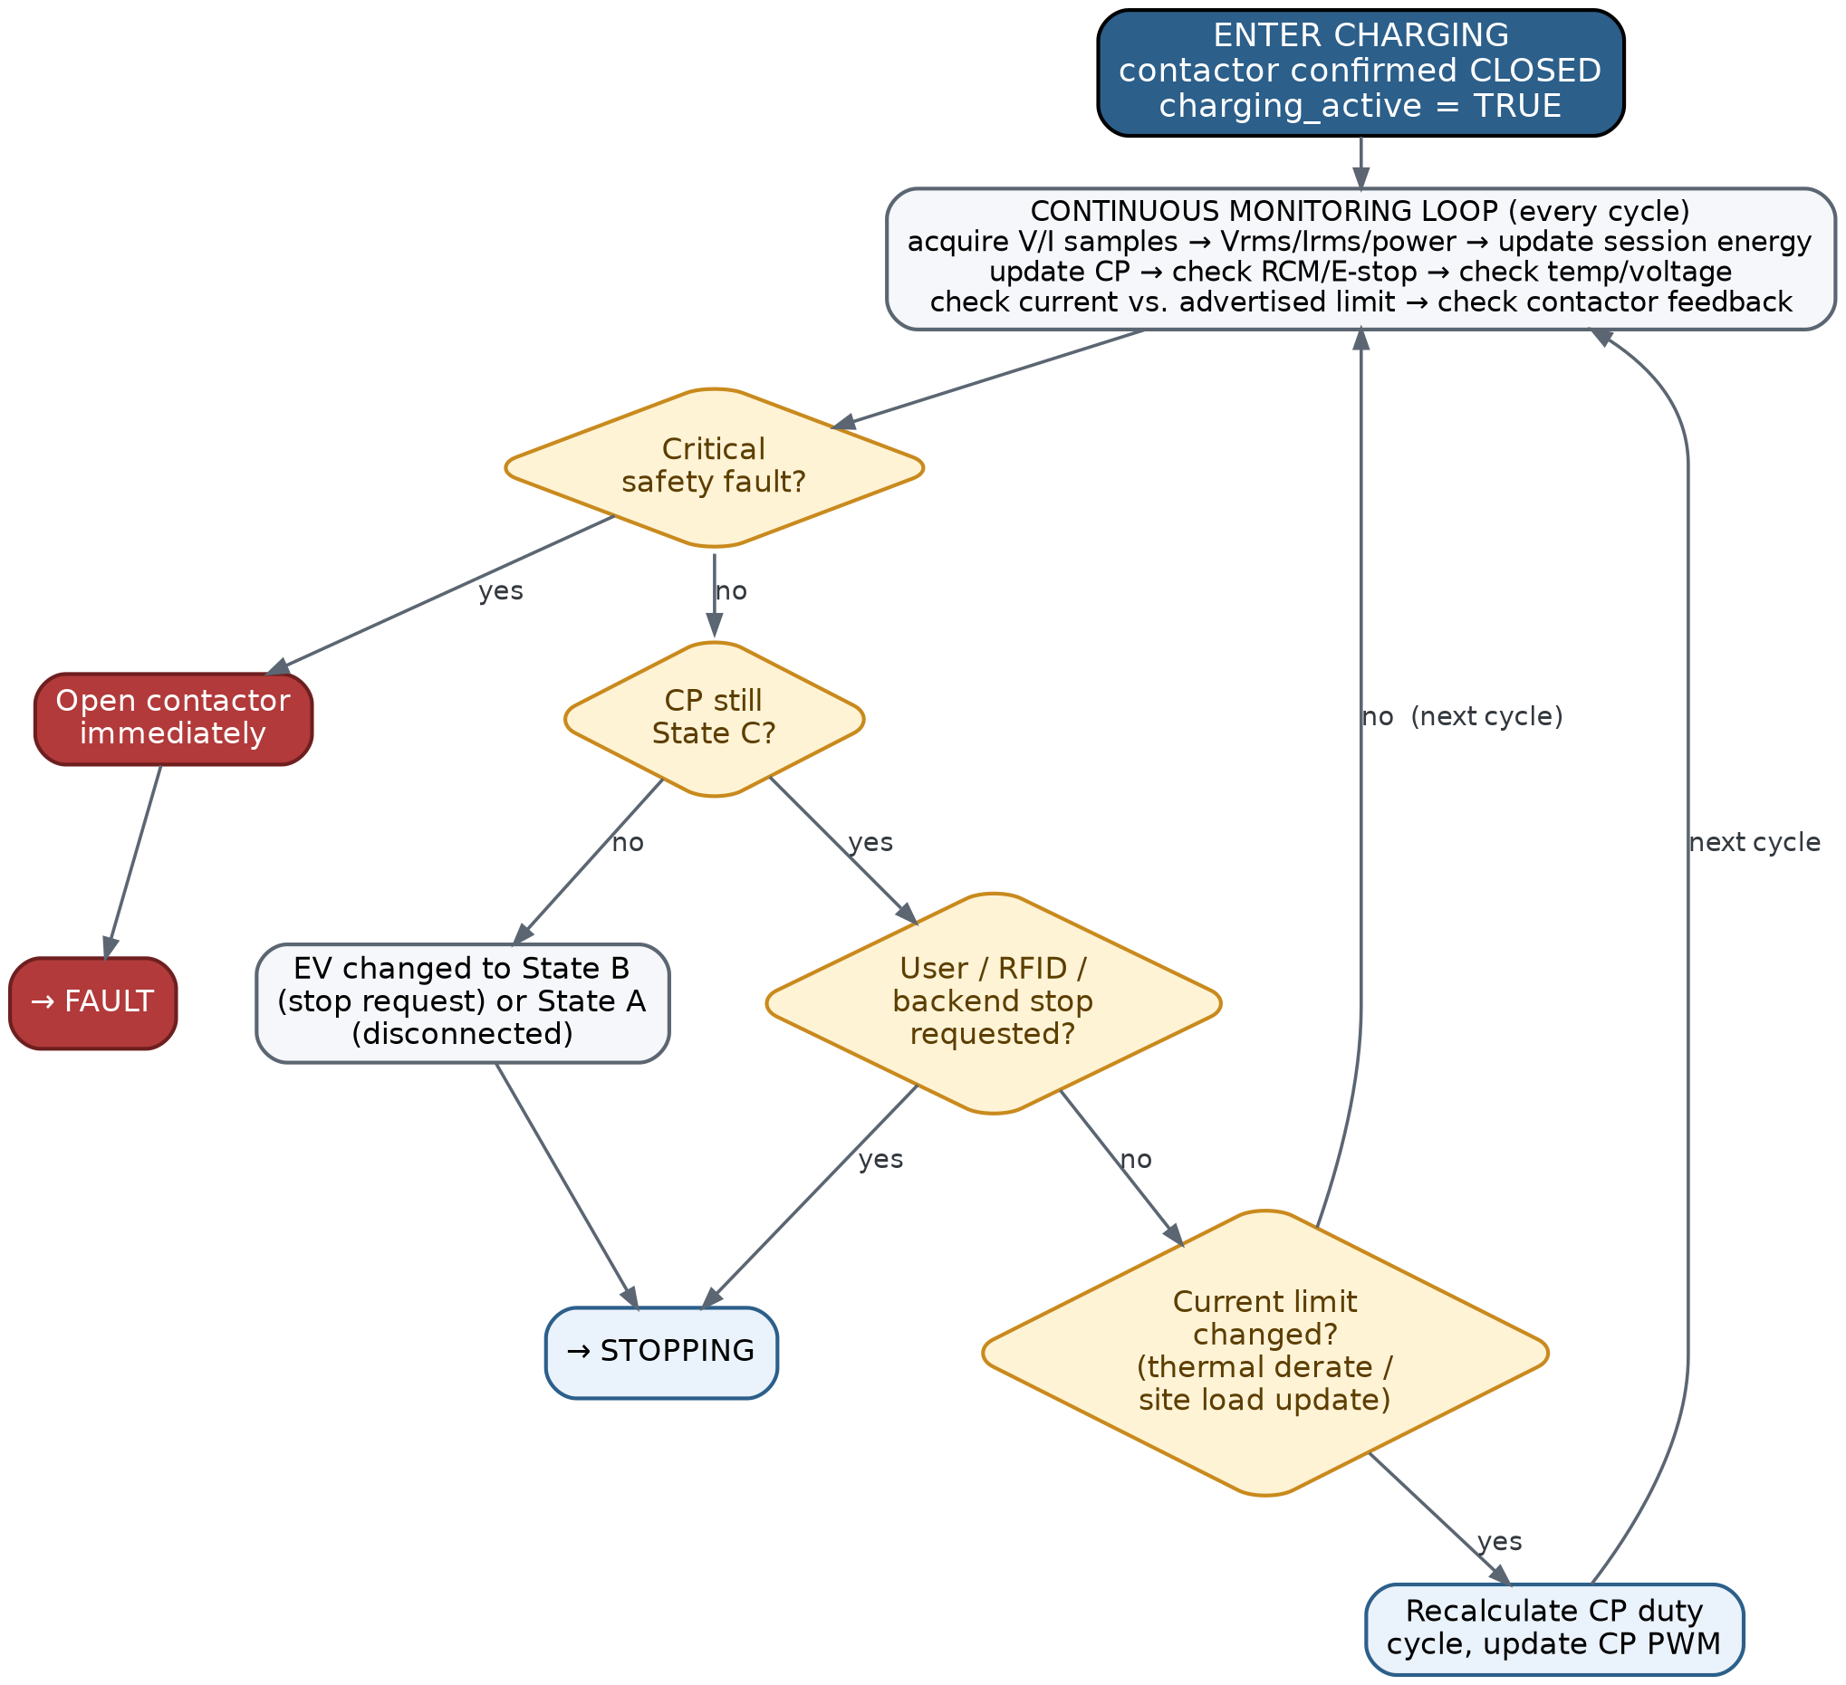
Figure 3. Charging — continuous monitoring loop.

State 10 — STOPPING
Purpose: Controlled transition from energized charging back to a safe, de-energized state — verify the contactor has actually opened and current has actually stopped before declaring the session over.
Entry conditions: From CHARGING, on any normal stop trigger (EV request, user/RFID/backend stop, session completion). A critical safety fault takes the separate immediate-shutdown path instead of this one.
Key activities & checks:
- Stop reason is recorded (EV request, user, RFID, backend, session complete, fault, disconnect) before anything else is cleared — this becomes the record of why the session ended.
- charging_requested is cleared and the contactor is commanded OFF.
- An opening timeout starts; feedback is polled until it reads OPEN or the timeout expires.
- Once open, measured current is confirmed to have actually dropped to a safe level — command and physical result are never assumed to match without verification.
Outputs: Contactor OFF; stop reason recorded; final energy figure captured.
Exit → next state(s): Contactor verified open and current stopped → SESSION END. Opening timeout expires, or current doesn't stop → FAULT.

State 11 — SESSION END
Purpose: Charging has already been safely stopped electrically. This state finalizes and reports the session's data, then decides what's next based on whether the EV is still plugged in.
Entry conditions: From STOPPING, with contactor OFF, feedback OPEN, and current ≈ 0.
Key activities & checks:
- Feedback is re-verified as OPEN.
- Metering is finalized — total energy and duration for the session.
- The full session record is assembled (stop reason, energy, duration, user/card ID) and queued for storage/backend reporting.
- Authorization is cleared and the session is marked ended.
- Current CP state is checked to decide the next state.
Outputs: Finalized session record queued for storage/backend reporting.
Exit → next state(s): EV no longer connected → IDLE. EV still connected → WAIT FOR UNPLUG.

State 12 — WAIT FOR UNPLUG
Purpose: The session has ended successfully, but the cable is still connected. Wait safely for the user to unplug before a new session can start.
Entry conditions: From SESSION END, with the EV still physically connected.
Key activities & checks:
- Contactor stays OFF (command OFF, feedback OPEN).
- Authorization and charging-request flags remain cleared.
- CP continues to be monitored for the vehicle being removed.
- A new authorization is deliberately not triggered automatically — the previous session has already ended, and the same physical connection doesn't imply automatic re-authorization for a new one.
Outputs: Contactor OFF; system idle-safe with the EV still attached.
Exit → next state(s): EV physically unplugged (CP returns to the no-vehicle condition) → IDLE, ready for a genuinely new connection.

State 13 — FAULT
Purpose: Put or keep the charger in a safe, de-energized state; identify and record what went wrong; inform the user and backend; and decide whether and how recovery is permitted. Reachable from virtually every other state.
Entry conditions: Any state, on a critical safety condition.
Key activities & checks:
- Critically, protective action — removing contactor drive — should already have begun at the point of detection, through the safety path itself. FAULT then manages the resulting safe state, diagnostics, and recovery; it is not what first opens the contactor.
- charging_requested is disabled and contactor OFF is held.
- Feedback is verified as actually OPEN — a mismatch here (feedback still CLOSED) indicates a possible welded/stuck contactor, which becomes its own additional fault.
- Current is confirmed to have actually stopped.
- A fault snapshot is captured: code, timestamp, charger state, V/I/T, CP state, contactor command/feedback, session ID.
- The in-progress session is finalized and preserved — not discarded — with stop reason = FAULT.
- User is notified (display/LED/buzzer) and a backend report is queued, both after protective action, never before.
- The fault is classified as a warning (derate only), recoverable (may auto-clear after a stable period), or critical/latched (requires manual/service reset).
Outputs: Fault record with distinct primary/secondary faults — a bitmask rather than a single overwritable flag, since more than one fault condition can be active at once; user/backend fault notification.
Exit → next state(s): Recoverable fault, condition cleared and stable for the required period → re-enter SELF TEST (never directly back to CHARGING) → pass → IDLE or WAIT FOR UNPLUG; fail → back to FAULT. Latched fault → remains in FAULT until a manual/service reset.
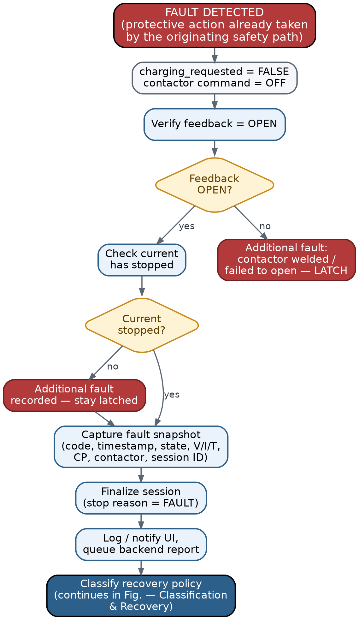
Figure 4a. Fault — detection & containment.
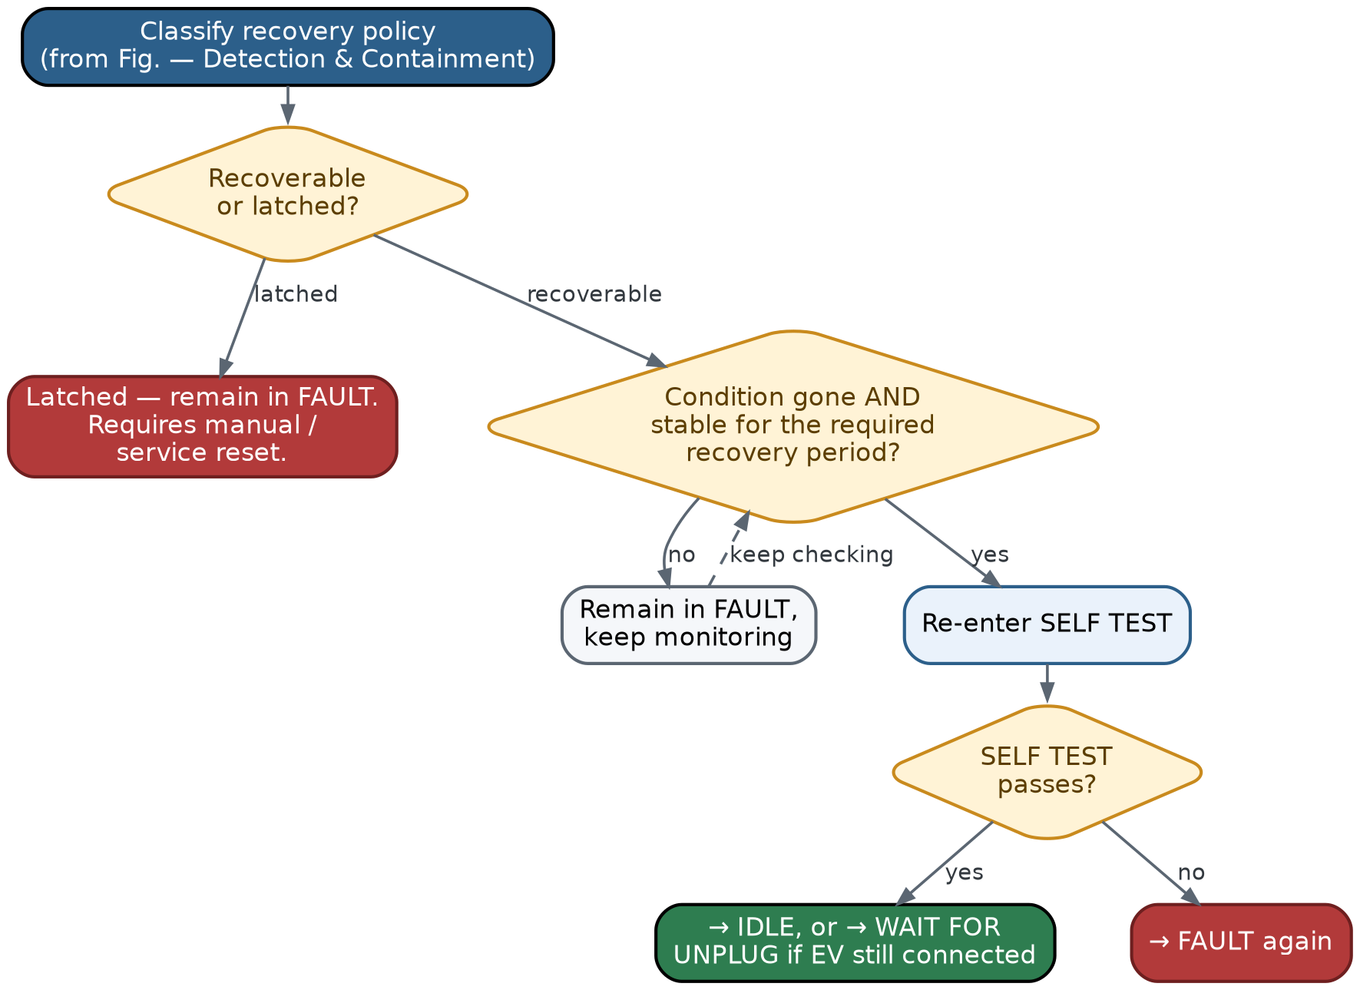
Figure 4b. Fault — classification & recovery.

Part B — Firmware Architecture
This section proposes a modular STM32-based firmware architecture derived from the flow in Part A. The design goals throughout: keep safety logic centralized and auditable, give the contactor a single owner, separate measurement from decision-making, and keep the main loop non-blocking so a slow subsystem (backend, RFID, display) can never delay a safety response.

B.1 Architecture Layers
The firmware is organized into four layers. The Application layer owns only sequencing — it decides when to ask other modules to act, never how. The Service layer holds all the actual domain logic (safety evaluation, fault classification, CP generation/measurement, contactor sequencing, metering, authorization, current-limit arbitration, communication, UI) behind clean APIs, so each piece is independently testable. The Hardware Abstraction Layer wraps STM32 peripherals so nothing above it touches a register directly.
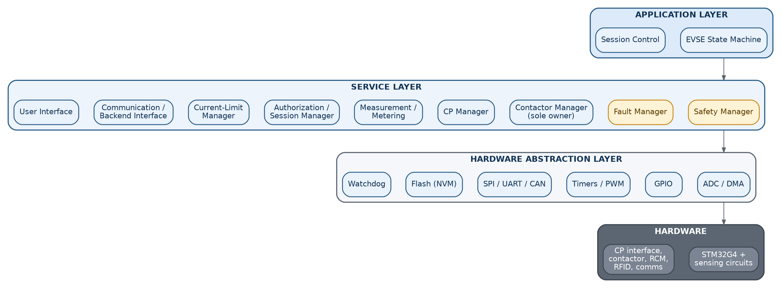
Figure 5. Firmware architecture layers and module map.

B.2 Module Responsibilities
Each service-layer module owns a specific slice of behavior and exposes it as an API — no module reaches into another module's internal state.
Module | Responsibility | Key Inputs | May Directly Control
EVSE State Machine | Orchestrates the 13-state sequence; decides when to request actions from other modules, never how they're carried out. | State from Safety/Fault/CP/Auth modules | Nothing electrical — issues requests only
Safety Manager | Continuously evaluates all safety-critical inputs and raises one safe/not-safe verdict plus which condition failed. | RCM, E-stop, Vrms/Irms, temperature, contactor feedback | Nothing directly — reports only
Fault Manager | Owns fault classification, the active-fault bitmask, snapshot capture, logging, and recovery-policy evaluation. | Safety Manager + module-reported faults | Nothing directly
Contactor Manager | Sole owner of the physical contactor output. Sequences command → feedback → timeout; detects failed-close / failed-open / welded conditions. | Open/close requests, contactor feedback GPIO | Contactor GPIO (only module allowed to)
CP Manager | Owns CP PWM generation (current limit → duty cycle) and CP measurement/state detection (A/B/C/D, validity, debounce). | Current limit, CP ADC samples | CP PWM timer
Measurement / Metering | ADC acquisition → RMS/power/energy calculation → engineering units → validity/staleness tracking. | Raw ADC samples | Nothing directly
Authorization / Session Manager | RFID/app/backend credential validation; owns session lifecycle (create, update, finalize). | RFID UID, backend response | Nothing directly
Current-Limit Manager | Arbitrates hardware rating, cable limit, site/backend limit, and thermal derating into one advertised current. | Thermal status, backend limit, ratings | Nothing directly → feeds CP Manager
Communication / Backend | Non-blocking backend/session/telemetry messaging; queues rather than blocking the control loop. | Backend requests/responses | Nothing directly
User Interface | LEDs, display, buzzer, local UI input. | UI events | UI outputs only
Diagnostics | Aggregates health/status info for service and backend visibility. | Module states | Nothing
HAL / Drivers | Thin wrappers over ADC, GPIO, timers, SPI, UART/CAN, flash, watchdog. | Register-level | Peripherals

B.3 State Machine Implementation Summary
A condensed cross-reference of all 13 states — see Part A for the full narrative and Figures 1–4 for the visual logic.
State | Entry Action (once) | Exit Condition | Next State(s)
1. Power On | Force safe output defaults | Basic startup OK / fails | Initialization / Fault
2. Initialization | Configure all peripherals, contactor OFF | All modules ready / fail | Self Test / Fault
3. Self Test | Contactor OFF, run health checks | All checks pass / any fail | Idle / Fault
4. Idle | Contactor OFF, CP idle signal | EV detected / critical fault | EV Connected / Fault
5. EV Connected | Create session record | EV removed / authorized / fault | Idle / Authorization / Fault
6. Authorization | Request credential | Accepted / rejected / EV removed / fault | Charging Prep / retry / Idle / Fault
7. Charging Prep | Compute & advertise current limit | EV ready (State C) / removed / fault | Final Safety Check / Idle / Fault
8. Final Safety Check | Re-verify all conditions fresh | All safe & closed / any fail | Charging / Fault / back to Prep
9. Charging | charging_active = TRUE | Stop request / EV stop / fault | Stopping / Fault
10. Stopping | Contactor OFF, start open timeout | Verified open & current stopped / timeout | Session End / Fault
11. Session End | Finalize metering & session record | EV connected? Y/N | Wait For Unplug / Idle
12. Wait For Unplug | Contactor OFF, monitor CP | EV unplugged | Idle
13. Fault | Contactor OFF, capture snapshot | Recovery permitted & stable / latched | Self Test / remain Fault

B.4 Safety Architecture

Fault severity classes
- Warning — condition is real but not yet dangerous (e.g. elevated temperature). Response: derate the advertised current, keep charging.
- Recoverable fault — charging stops, but if the condition clears and stays clear for a defined stable period, automatic recovery through SELF TEST is permitted (e.g. transient undervoltage).
- Critical / latched fault — charging is prohibited until a manual or service reset (e.g. RCM fault, contactor integrity fault). The firmware deliberately does not auto-clear these, to avoid a fault → reset → retry → fault cycle.

Where firmware alone is not the protection boundary
For RCM/leakage and emergency-stop class conditions in particular, firmware monitoring and an orderly software response are not a substitute for an independent, hardware-level disconnect path where applicable safety requirements call for one. Firmware's role there is detection, logging, orderly shutdown sequencing, and recovery policy — not the sole protective mechanism.

B.5 Contactor Control Ownership
- Only the Contactor Manager ever writes the contactor GPIO. Every other module — including the state machine — only requests open/close through its API; nothing else has a path to the pin.
- Command and feedback are tracked as two independent variables, cross-checked continuously: command = OFF with feedback = CLOSED flags a possible weld; command = ON with feedback still OPEN past a timeout flags a failed close.
- The hardware default (no MCU command, or MCU in reset) must equal contactor OFF. On any reset, firmware always re-enters POWER ON → INITIALIZATION → SELF TEST — it never resumes a prior charging_active = true state.

B.6 Control Pilot (CP) Subsystem
CP generation and CP measurement are kept as clearly separated concerns inside one CP Manager module:
- Generation: current limit → duty-cycle calculation → PWM timer → CP driver. Purely an output path.
- Measurement / state detection: CP ADC samples → positive/negative level extraction → debounce/stability window → A/B/C/D classification → validity flag. Purely an input path.
Keeping these separate internally (even though they're one logical subsystem externally) means a measurement problem can never be masked by, or accidentally influence, the generation path.

B.7 Measurement Architecture
A consistent pipeline is used for every measured quantity (voltage, current, temperature):
- ADC acquisition — DMA-driven; the ISR only marks a buffer ready, it does not process data.
- Signal processing — bias removal, RMS calculation.
- Engineering-unit conversion — raw counts → volts / amps / °C.
- Validation — range check plus a staleness check against a timestamp.
- Consumption — only validated, fresh values reach Safety Manager, Metering, and the state machine.
Stale or invalid data is treated as unsafe and triggers a fault path — the firmware never silently continues on the last known-good value indefinitely.

B.8 Fault Record Structure
A single fault flag loses information. Each fault is instead captured as a record:
typedef struct {
FaultCode_t code; // primary cause
uint32_t active_faults; // bitmask - multiple faults can coexist
uint32_t timestamp;
ChargerState_t charger_state;
float voltage, current, temperature;
CP_State_t cp_state;
bool contactor_command, contactor_feedback;
uint32_t session_id;
} FaultRecord_t;
The bitmask matters in practice: an RCM fault can be followed moments later by a contactor-failed-to-open condition, and both need to remain visible rather than the second overwriting the first.

B.9 Execution Model
A deterministic, non-blocking super-loop is sufficient for this system — nothing in the flow requires an RTOS on its own. The main loop stays short and predictable:
while (1) {
Measurement_Update(); // ADC -> RMS -> validated values
CP_Update(); // measure + drive CP
Safety_Update(); // evaluate all safety inputs
Communication_Update(); // non-blocking backend I/O
RFID_Update(); // non-blocking reader poll
EVSE_StateMachine(); // one state's logic, then return
UI_Update(); // LEDs / display / buzzer
Watchdog_Service();
}
Interrupt guidance: ADC-complete and timer ISRs capture data or set a flag and return — nothing state-related, communication-related, or session-related ever runs in interrupt context. Heavy processing always happens back in the main loop.

B.10 Suggested STM32CubeIDE Project Structure
Core/ main.c, startup, HAL config
Drivers/ BSP wrappers: adc.c, gpio.c, timer_pwm.c,
spi.c, uart_can.c, flash.c, watchdog.c
Application/ evse_state_machine.c/.h, session_control.c/.h
Services/ safety_manager.c/.h
fault_manager.c/.h
contactor_manager.c/.h
cp_manager.c/.h
measurement.c/.h
authorization_manager.c/.h
current_limit_manager.c/.h
comm_backend.c/.h
user_interface.c/.h
diagnostics.c/.h
BSP/ board-specific pin maps, hardware config

